CS800 Number Theory and Cryptography
Lab Report



Vidit Prashant Gala (252IS012)
I SEMESTER 2025-26

submitted to Mr. M.P. Singh sir

Department of Computer Science and Engineering

National Institute of Technology Karnataka, Surathkal
PO Srinivasnagar, Mangaluru-575025, Karnataka

2025-26

Index

- Experiment 1 - Basics of python Pg 4-7

- Experiment 2 - Python basic programs Pg 8-12

- Experiment 3 - GCD & Divisibility related programs Pg 13-18
- GCD using Euclidean algorithm
- Extended Euclidean algorithm
- Numbers with K odd divisors
- N divisors in a given range
- gcd (85, 289) using Euclid's extended algorithm
- No. of steps in Euclid's extended algorithm
- Prove (m, n) = 1, then (m+n, m-n) = 1 or 2.

- Experiment 4 - Diophantine equation programs Pg 19-23
- Solve Diophantine equations
- GCD using Euclidean algorithm
- Set of 2 or more integers, find their GCD
- Divisible by 10 test of array
- Minimum operations to make A and B to be divisible by 3
- List numbers that are divisible by 2 or 3 or 5 in a range

- Experiment 5 - Prime numbers related programs Pg 24-36

- Experiment 6 - Mixture of GCD and Primes programs Pg 37-40
- Twin primes
- Primes of form n^2 + 1
- Smallest prime factor of n! + 1
- Determine whether a number is prime or not
- Euclidean algorithm to find gcd
- Set of 2 or more numbers, find their gcd

- Experiment 7 - Symmetric cipher related programs Pg 41-64

Substitution Ciphers:-
- Ceaser Cipher
- Monoalphabetic Cipher (Affine cipher)
- Playfair Cipher
- Hill Cipher
- Vignere Cipher
- Autokey Cipher
- Vernam Cipher
- One-time pad Cipher
- Kasiski Method

Transposition Ciphers:-
- Railfence Cipher
- Row Column Cipher
Product Ciphers:-
- 2 substitutions
- 2 transpositions
- Substitution + Transposition

- Experiment 8 - Asymmetric cipher related programs Pg 65-73
- Diffie-Hellman Key Exchange
- Elgamal
- RSA
- PseudoRandom Key generation
- SHA1
- MD5
- HMAC
- Digital signature - RSA, Elgamal, Schnorr

- Experiment 9 - Elliptic Curve Cryptography Pg 74-77

EXPERIMENT 1

A. Basics (Data types, array length)
for i in range(0,6):
print(i)

z = int(2)
y = int(3.5)
x = float(2)
print(x,y,z)

a = "Vidit Gala"
print(len(a))
print(a[0:3])
print(type(a))

b = 5
print(type(b))

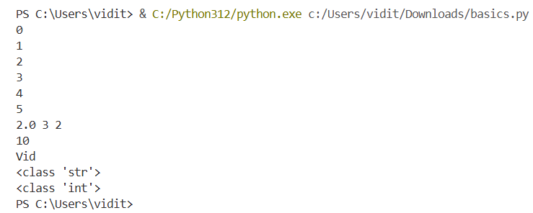

B. Switch case for GCD and Calculator
def gcd_recursive(a,b):
print("Greatest Common Divisor!")
if b == 0:
return a
else:
return gcd_recursive(b, a % b)

def Calculator():
print("Welcome to Calculator")
a = int(input("Enter the 1st number: "))
b = int(input("Enter the 2nd number: "))
opt = 0
while(opt!=5):
opt = int(input("Enter 1 to perform add, 2 for subtract, 3 for multiply, 4 for division, and 5 to exit: "))
match opt:
case 1: print(a+b)
case 2: print(a-b)
case 3: print(a*b)
case 4: print(a/b)
print("Thank You!")

choice = int(input("Enter 1 for GCD, Enter 2 for Calculator: "))
match choice:
case 1:
x = int(input("Enter the 1st number: "))
y = int(input("Enter the 2nd number: "))
res = gcd_recursive(x,y)
print(res)
case 2:
Calculator()

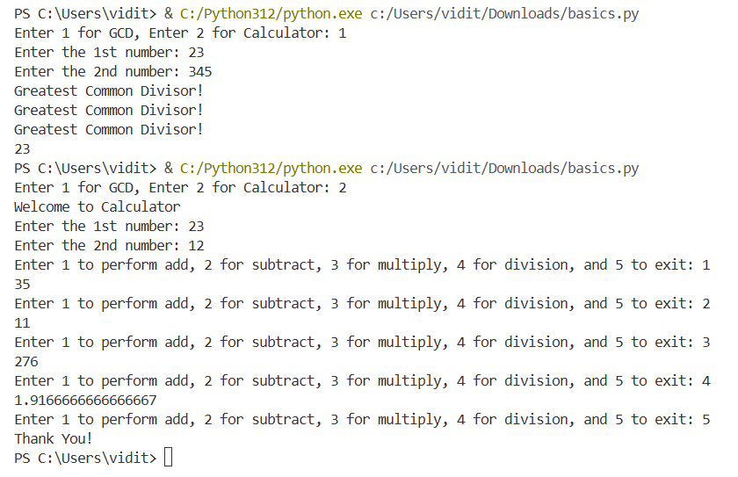
C. Star Pattern
n = int(input("Enter the value of n: "))
for i in range(1,n+1):
for j in range(0,i):
print("*", end = "")
print()
for i in range(n-1,0,-1):
for j in range(i,0,-1):
print("*", end = "")
print()
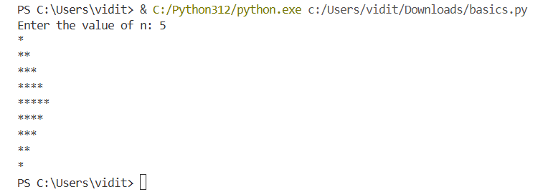

D. Finding a number in an array, then calculating its square
a = []
for i in range(5):
b = int(input("Enter a value: "))
a.append(b)

print(a)

num = int(input("Enter the number to find: "))

if num in a:
print("Number found!")
print("Square of the number is", num*num)
else:
print("number not found!")
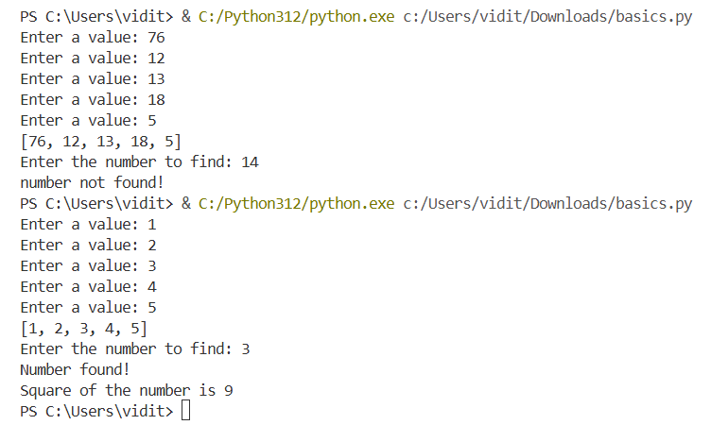

EXPERIMENT 2

A. Students with the highest marks to find in dictionary
scores = {"Alice": 88, "Bob": 95, "Charlie": 70, "David": 95, "Eve": 88} # students with highest marks to find
high = max(scores.values())
print(high)
st = [name for name, sc in scores.items() if sc == high]
# if(scores.values == high):
print(st)

B. Check if list has duplicate elements only using a set
nums = [1,2,3,4,2,5,6,3] # check if list has duplicate elements only using a set
s = set()
for i in range(len(nums)):
s.add(nums[i])
print(s)
if len(s)<len(nums):
check = True
else:
check = False
print(check)
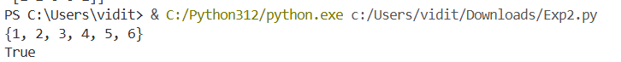

C. Symmetric diff
a = {1,2,3,4,5}
b = {4,5,6,7,8}

diff = a.union(b) - a.intersection(b)
print(diff)
D. Top 2 most frequent elements
list_nums = [2,3,5,2,3,7,11,5,2] # top 2 most freq elems
maxim = list_nums.count(list_nums[0])
maxis = 0
for i in range(len(list_nums)):
n = list_nums.count(list_nums[i])
if n>maxim:
maxim = n
ind = i
elif n<maxim and n>maxis:
maxis = n
index = i
print(f"1st Frequency->", maxim, "1st Elem->", list_nums[i])
print(f"2nd Frequency->", maxis, "2nd Elem->", list_nums[index])
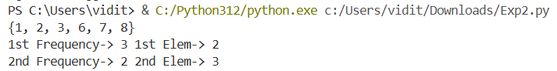

E. Flattening a list
flat_nums = [1,2,3,[4,5],(6,7),[8,[9,10]]]
lit = []

# print(len(flat_nums[5]))
def flatt(flat_nums):
for i in range(len(flat_nums)):
if type(flat_nums[i]) == list or type(flat_nums[i]) == tuple:
flatt(flat_nums[i])
else:
lit.append(flat_nums[i])
flatt(flat_nums)
print(lit)

F. Function inside a function
flat_nums = [1,2,3,4,5,6,7,8,9,10]
lit = []

def sum(flat_nums):
sum=0
for i in range(len(flat_nums)):
sum = sum + flat_nums[i]
return sum

# print(len(flat_nums[5]))
def flatt(flat_nums):
s = sum(flat_nums)
print(s)

flatt(flat_nums)

G. Tuple
li = [(1,2),(3,4),(5,6)]
tu = ()
new = []
# print(len(li))
for i in range(len(li)):
s = sum(li[i])
# print(s)
new.append(s)

# print(new)
tu = tuple(new)
print(tu)

H. Prefix finding
words = ["flower", "flow", "flight", "app", "banana"]
new_li = []
for i in range(len(words)):
for j in range(i+1, len(words)):
if set(words[i]) & set(words[j]):
print(words[i], words[j])

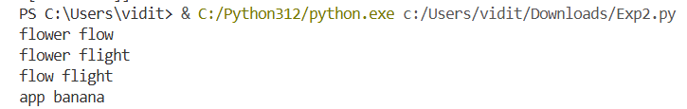

I. Sum of list
list_int = [1,2,3,4,5,1,2]
li=[]
s = set()
def exact(list_int):
for i in range(len(list_int)):
if list_int.count(list_int[i]) == 2:
s.add(list_int[i])

# exact(list_int)
print(s)
li = list(s)
print(li)

J. Tuple
import numpy as np

arr= np.random.rand(5, 5)
arr_int = np.random.randint(0, 10, size=(5, 5))
print(arr_int)
sum=0
# s = sum(arr_int)
# print(s)
for i in range(5):
for j in range(5):
sum = sum + arr_int[i][j]

print(sum/25)
for i in range(5):
for j in range(5):
if arr_int[i][j] > (sum/25):
arr_int[i][j] = 1
else:
arr_int[i][j] = 0

print(arr_int)
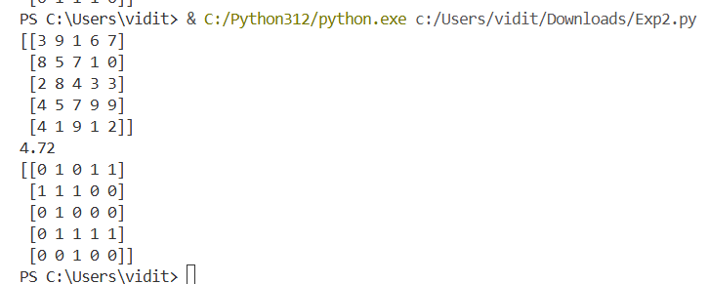

EXPERIMENT 3

A. Print hello world
print("Question 2 ============")
print("Hello World")
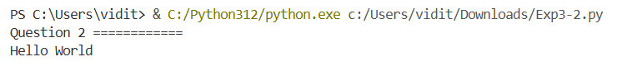

B. Does b divide a?
print("\nQuestion 3 ============")
a = int(input("Enter a number (a): "))
b = int(input("Enter a number (b) and b should not be 0:"))
if b == 0:
print("Enter the value again")
b = int(input("Enter a number (b) and b should not be 0:"))

if a%b == 0:
print("This is true - b | a")
else:
print("This is false - b | a")
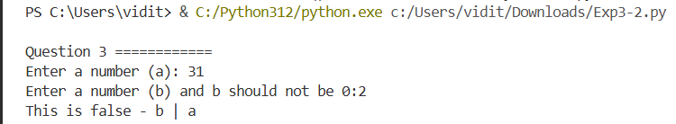

C. Find gcd by d max
print("\nQuestion 4 ============")
n1 = int(input("Enter a: "))
n2 = int(input("Enter b: "))

minim = min(n1,n2)
maxim = 0
if n1 == 0:
maxim = n2
if n2 == 0:
maxim = n1
for i in range(1,minim+1):
if n1%i == 0 and n2%i == 0:
d = i
maxim = max(d,maxim)

print(maxim)
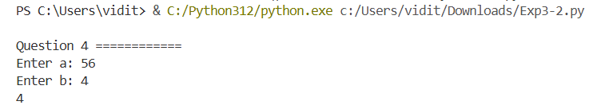

D. Find gcd by euclid
print("\nQuestion 5 ============")
def gcd_recursive(a,b):
if b == 0:
return a
else:
return gcd_recursive(b, a % b)

m1 = int(input("Enter a number (a): "))
m2 = int(input("Enter a number (b): "))
num = gcd_recursive(m1, m2)
print(num)
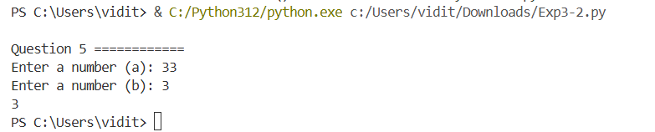

E. Recursive gcd
print("\nQuestion 5 ============")
def gcd_recursive(a,b):
if b == 0:
return a
else:
return gcd_recursive(b, a % b)

m1 = int(input("Enter a number (a): "))
m2 = int(input("Enter a number (b): "))
num = gcd_recursive(m1, m2)
print(num)
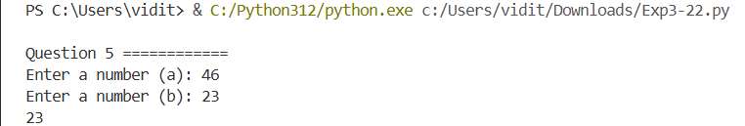

F. Find d = ax + by, where d = (a, b)
print("\nQuestion 6 ============")
n1 = int(input("Enter a number (a): "))

n2 = int(input("Enter a number (b): "))
def gcd(n1,n2):
if n1 == 0:
return(n2,0,1)
else:
d,x1,y1 = gcd(n2%n1, n1)
x = y1 - (n2//n1)*x1
y = x1
return(d,x,y)

d, x, y = gcd(n1,n2)
print(d,x,y)
print(n1,"*",x,"(x)","+",n2,"*",y,"(y)","=",d)
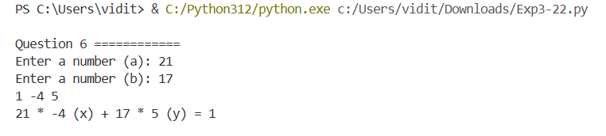
G. Find count of numbers that have k divisors in a range
print("\nQuestion 7 ============")
a = int(input("Enter a number (a): "))
b = int(input("Enter a number (b): "))
k = int(input("Enter a number (k): "))
ans = 0
for i in range(a+1, b+1):
count = 0
for j in range(1,i+1):
if i%j == 0:
count = count + 1
if count == k:
ans = ans + 1

print(ans)
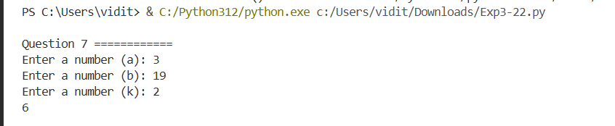
H. Find count of numbers and print them that have k divisors in a range
print("\nQuestion 8 ============")
a = int(input("Enter a number (a): "))
b = int(input("Enter a number (b): "))
n = int(input("Enter a number (n): "))
s = set()
ans = 0
for i in range(a+1, b+1):
count = 0
for j in range(1,i+1):
if i%j == 0:
count = count + 1
if count == n:
ans = ans + 1
s.add(i)

print(ans)
print(s)
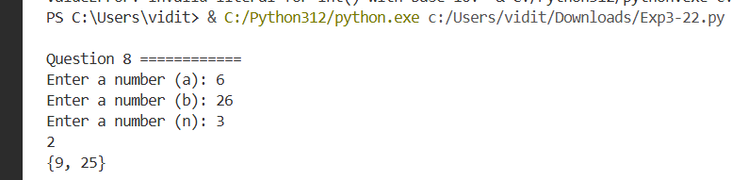
I. Find d for (85, 289) and also x, y
print("\nQuestion 9 ============")
n1 = 85
n2 = 289
def gcd(n1,n2):
if n1 == 0:
return(n2,0,1)
else:
d,x1,y1 = gcd(n2%n1, n1)
x = y1 - (n2//n1)*x1
y = x1
return(d,x,y)

d, x, y = gcd(n1,n2)
print(d,x,y)
print(n1,"*",x,"(x)","+",n2,"*",y,"(y)","=",d)
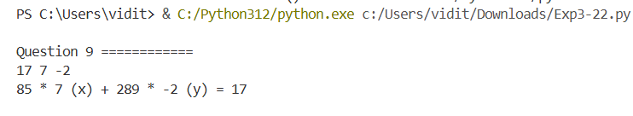
J. Find number of steps to find gcd
print("\nQuestion 10 ============")
def gcd_recurs(a,b,k):
if b == 0:
k = k+1
return a, k
else:
k = k+1
return gcd_recurs(b, a % b,k)

m1 = int(input("Enter a number (a): "))
m2 = int(input("Enter a number (b): "))
k = 0
num,ans = gcd_recurs(m1, m2,k)
print(num)
print("The number of steps are: ", ans)
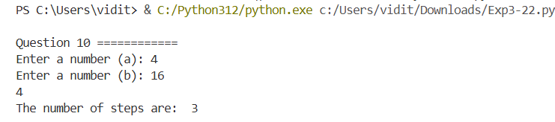

K. GCD of (m1+m2, m1-m2) = 1 or 2 iff gcd(m1, m2) = 1
print("\nQuestion 11 ============")
def gcd_recursive(a,b):
if b == 0:
return a
else:
return gcd_recursive(b, a % b)

m1 = int(input("Enter a number (a): "))
m2 = int(input("Enter a number (b): "))
num = gcd_recursive(m1, m2)
if num == 1:
num1 = gcd_recursive(m1+m2,m1-m2)
print("GCD of ", m1+m2, "and", m1-m2, "is: ")
print(num1)
else:
print("GCD IS NOT 1")
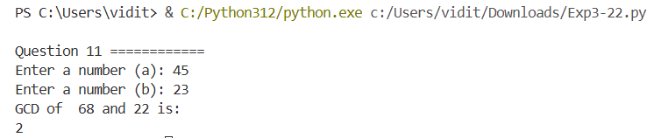

EXPERIMENT 4

A. Solve diophantine equations
import math
def extended_gcd(a, b):
if a == 0:
return b, 0, 1
gcd, x1, y1 = extended_gcd(b % a, a)
x = y1 - (b // a) * x1
y = x1
return gcd, x, y
def solve_linear_diophantine(a, b, c):
gcd, x0, y0 = extended_gcd(a, b)

if c % gcd != 0:
return "No integer solutions exist."

x_1 = x0 * (c // gcd)
y_1 = y0 * (c // gcd)

b_p = b // gcd
a_p = a // gcd

def get_solution(k):
x_k = x_1 + k * b_p
y_k = y_1 - k * a_p
return x_k, y_k

return get_solution, gcd
a = 56
b = 72
c = 40
solution_generator, common_divisor = solve_linear_diophantine(a, b, c)
if isinstance(solution_generator, str):
print(solution_generator)
else:
print(f"GCD({a}, {b}) = {common_divisor}")
print("General solutions (x, y) for 56x + 72y = 40:")
for k in range(-10,10):
x, y = solution_generator(k)
print(f"k = {k}: x = {x}, y = {y}")
a = 24
b = 138
c = 18
solution_generator, common_divisor = solve_linear_diophantine(a, b, c)
if isinstance(solution_generator, str):
print(solution_generator)
else:
print(f"GCD({a}, {b}) = {common_divisor}")
print("General solutions (x, y) for 24x + 138y = 18:")
for k in range(-10,10):
x, y = solution_generator(k)
print(f"k = {k}: x = {x}, y = {y}")
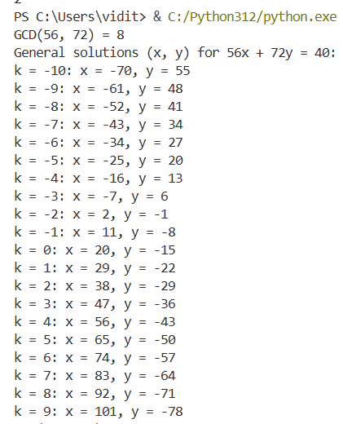
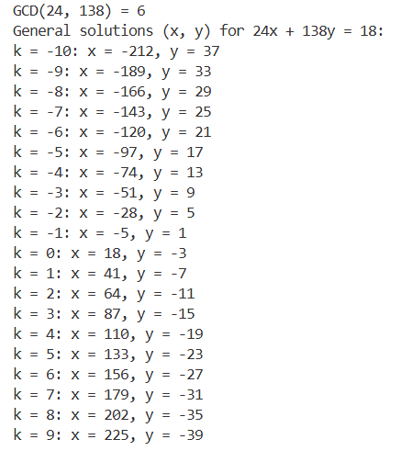
B. Recursive gcd
print("\nQuestion 2 ============")
def gcd_recursive(a,b):
if b == 0:
return a
else:
return gcd_recursive(b, a % b)

m1 = int(input("Enter a number (a): "))
m2 = int(input("Enter a number (b): "))
num = gcd_recursive(m1,m2)
print(num)
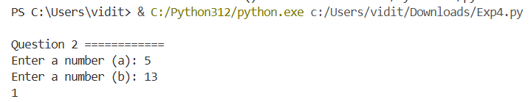
C. Gcd of a list
print("\nQuestion 3 ============")
a = [6,3]
for i in range(4):
x = int(input("Enter number:-"))
a.append(x)
print(a)
def gcd_recursive(a,b):
if b == 0:
return a
else:
return gcd_recursive(b, a % b)
g = gcd_recursive(a[0],a[1])
d = g
for i in range(2,5):
d = gcd_recursive(d,a[i])
print(d)
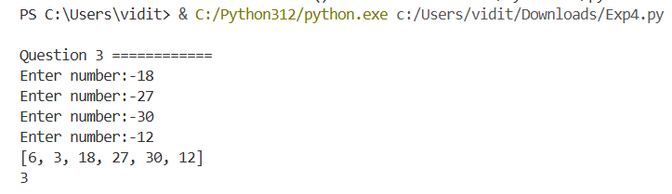
D. If array number is mod 10 or not?
print("\nQuestion 4 ============")
arr = []
n = int(input("Enter value of n: "))
for i in range(n):
val = int(input("Enter array values: "))
arr.append(val)
print(arr)
s = ""
for i in range(n):
v = arr[i]%10
s = s + str(v)
n = int(s)
print(n)
if n%10 == 0: print("TRUE")
else: print("False")
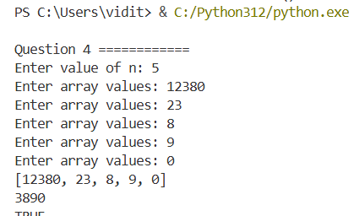

E. Number of steps to convert a or b to 0mod3
print("\nQuestion 5 ============")
a = int(input("Enter the value of a: "))
b = int(input("Enter the value of b: "))
count = 0
while a%3!=0 and b%3!=0:
if a>b:
a = abs(a-b)
else:
b = abs(a-b)
count = count+1

print("No.of steps = ", count)
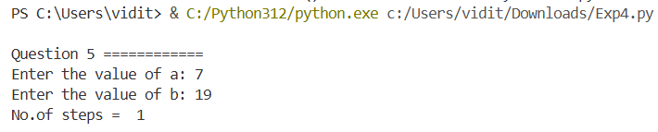
F. Count of numbers divisible by 2 or 3 or 5 in a range
print("\nQuestion 6 ============")
a = int(input("Enter the value of a: "))
b = int(input("Enter the value of b: "))
arr = []
for i in range(a,b+1):
if i%2==0 or i%3==0 or i%5==0:
arr.append(i)

print(arr)
print(len(arr))
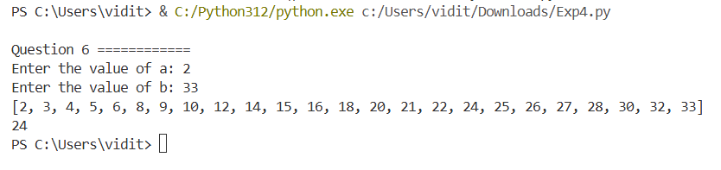

EXPERIMENT 5

A. Find 2 primes whose sum = n
a = int(input("Enter a number(>2): "))
def isPrime(n):
for i in range(2,n):
if n%i == 0: return False
return True

li = []
for i in range(2,a):
if(isPrime(i)):
li.append(i)

print(li)
check = False
for i in range(len(li)):
for j in range(i+1,len(li)):
if li[i] + li[j] == a:
check = True
print(li[i], li[j])
break
else:
check = False
if check==True:
break

if(check==False): print(-1)
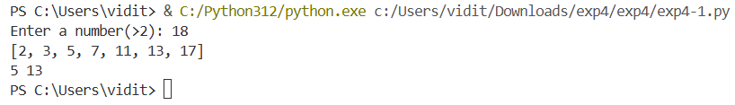
B. Prove that for even n, there exist primes p and q (n-p, n-q) = 1.
n = int(input("Enter a number(>6): "))
def isPrime(n):
for i in range(2,n):
if n%i == 0: return False
return True

def gcd_recursive(a,b):
if b == 0:
return a
else:
return gcd_recursive(b, a % b)

li = []
for i in range(2,n):
if(isPrime(i)):
li.append(i)

for i in range(len(li)-2):
num = gcd_recursive(n-li[i],n-li[i+2])
print(num, "p and q are: ", li[i], li[i+2])
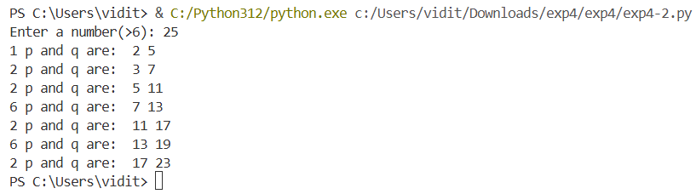
C. Find all primes as sums and differences of two primes
n = int(input("Enter a number: "))
def isPrime(n):
for i in range(2,n):
if n%i == 0: return False
return True

li = []
for i in range(2,n):
if(isPrime(i)):
li.append(i)
print(li)
count = 0
for i in range(2,n):
if(isPrime(i)):
for j in range(len(li)):
for k in range(j+1,len(li)):
if i == li[j] + li[k]:
count = count + 1
ans = i
# print(i,li[j],li[k])
for j in range(len(li)):
for k in range(j+1,len(li)):
if i == li[k] - li[j]:
count = count + 1
ans = i
# print(i,li[j],li[k])
if count == 2: print(i)
else: count = 0
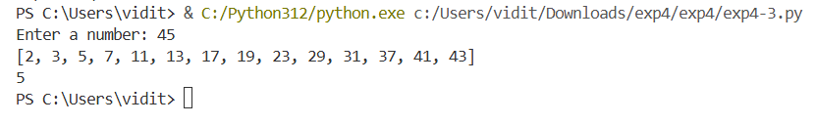
D. Find three least positive integers n such that there are no primes between n and n + 10, and three least positive integers m such that there are no primes between 10m and 10(m+1)
n = int(input("Enter a number: "))
def isPrime(n):
for i in range(2,n):
if n%i == 0: return False
return True

li = []
for i in range(2,n):
if not any(isPrime(j) for j in range(i,i+11)):
print(i)
li.append(i)
if(len(li) == 3):
break
if(len(li) == 3):
break
lm = []
for i in range(2,n):
if not any(isPrime(j) for j in range(10*i,10*i + 11)):
print(i)
lm.append(i)
if(len(lm) == 3):
break
if(len(lm) == 3):
break

print(li)
print(lm)
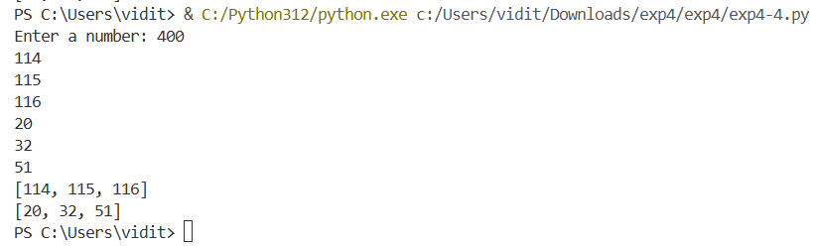
E. Find four solutions of the equation p^2+ 1 = q^2+r^2 primes
# p^2 + 1 = q^2 + r^2 p,q,r are primes
n = int(input("Enter a number: "))
def isPrime(n):
for i in range(2,n):
if n%i == 0: return False
return True

count = 0
li = []
for i in range(2,n):
if(isPrime(i)):
for j in range(2,n):
if(isPrime(j)):
for k in range(2,n):
if(isPrime(k)):
if i*i + 1 == j*j + k*k:
count = count+1
# print(i,j,k)
li.append((i,j,k))
if(count==6): break
if(count==6): break
if(count==6): break
print(li)
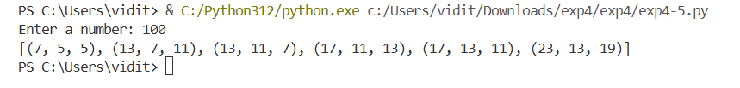

F. Find all prime solutions of the equation p(p+1)+q(q+1) = r(r+1)
n = int(input("Enter a number: "))
def isPrime(n):
for i in range(2,n):
if n%i == 0: return False
return True

count = 0
li = []
for i in range(2,n):
if(isPrime(i)):
for j in range(2,n):
if(isPrime(j)):
for k in range(2,n):
if(isPrime(k)):
if i*(i+1) + j*(j+1) == k*(k+1):
li.append((i,j,k))
break
print(li)

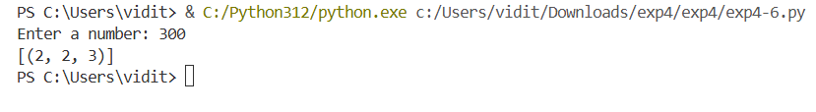
G. Find all primes numbers p(p+1), q(q+1), r(r+1) form an AP
n = int(input("Enter a number: "))
def isPrime(n):
for i in range(2,n):
if n%i == 0: return False
return True

li = []

for i in range(2,n):
if(isPrime(i)):
for j in range(2,n):
if(i==j): continue
if(isPrime(j)):
for k in range(2,n):
if(i==k or j==k): continue
if(isPrime(k)):
if (j*(j+1) - i*(i+1)) == (k*(k+1) - j*(j+1)):
li.append((i,j,k))
break
print(li)
print(len(li))
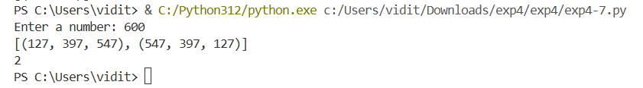
H. Find integers n where n+1, n+3, n+7, n+9, n+13, and n+15 = prime
n = int(input("Enter a number: "))
def isPrime(n):
for i in range(2,n):
if n%i == 0: return False
return True

li = []
for i in range(2,n):
if(isPrime(i+1)):
if(isPrime(i+3)):
if(isPrime(i+7)):
if(isPrime(i+9)):
if(isPrime(i+13)):
if(isPrime(i+15)):
li.append(i)
print(i)

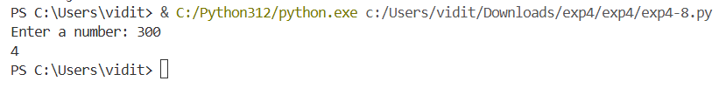
I. Find five primes that are sums of two fourth powers of integers
n = int(input("Enter a number: "))
def isPrime(n):
for i in range(2,n):
if n%i == 0: return False
return True

li = []
for i in range(2,n):
if(isPrime(i)):
li.append(i)
count = 0
for i in range(1,n):
for j in range(i,n):
ans = pow(i,4)+pow(j,4)
for k in range(len(li)):
if li[k] == ans:
count= count + 1
print(ans, "i & j are", i, j)
if(count == 5): break
if(count == 5): break
if(count == 5): break
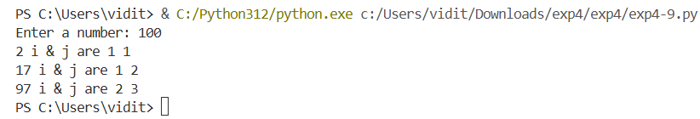

J. Prove that there are infinite pairs of consecutive primes that are not twin primes
n = int(input("Enter a number: "))
def isPrime(n):
for i in range(2,n):
if n%i == 0: return False
return True

li = []
for i in range(2,n):
if(isPrime(i)):
li.append(i)
ans = []
for i in range(len(li)-1):
for j in range(i+1,len(li)):
if(li[j] - li[i] !=2):
ans.append((li[i],li[j]))
print(ans)
print(len(ans))
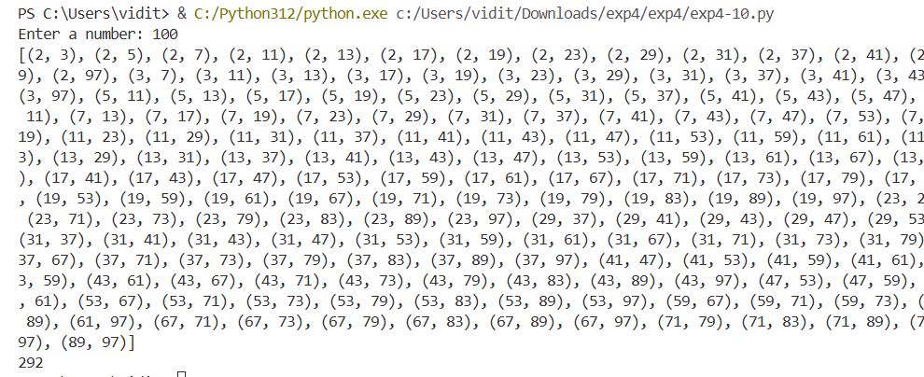

K. Find 5 integers for n^2-1 is a product of three different primes.
n = int(input("Enter a number: "))
def isPrime(n):
for i in range(2,n):
if n%i == 0: return False
return True

li = []
for i in range(2,n):
if(isPrime(i)):
li.append(i)
print(li)

ans = []
count = 0
for i in range(len(li)):
for j in range(i+1,len(li)):
for k in range(j+1,len(li)):
for z in range(1,n):
if z*z - 1 == li[i]*li[j]*li[k]:
count = count + 1
print(z, " - ", li[i],li[j],li[k])
ans.append(z)
if(count == 5): break
if(count == 5): break
if(count == 5): break
if(count == 5): break

print(ans)
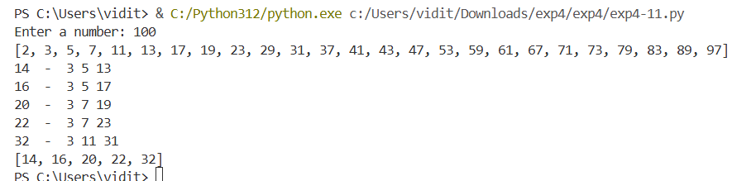
L. Find five least positive integers n for which n^2+1 is a product of three different primes, and find a positive integer n for which n^2+1 is a product of three different odd primes.
n = int(input("Enter a number: "))
def isPrime(n):
for i in range(2,n):
if n%i == 0: return False
return True

li = []
for i in range(2,n):
if(isPrime(i)):
li.append(i)
print(li)

ans = []
count = 0
for i in range(len(li)):
for j in range(i+1,len(li)):
for k in range(j+1,len(li)):
for z in range(1,n):
if z*z + 1 == li[i]*li[j]*li[k]:
count = count + 1
print(z, " - ", li[i],li[j],li[k])
ans.append(z)
if(count == 5): break
if(count == 5): break
if(count == 5): break
if(count == 5): break

print(ans)
n = int(input("Enter a number: "))
def isPrime(n):
for i in range(2,n):
if n%i == 0: return False
return True

li = []
for i in range(2,n):
if(isPrime(i)):
if(i%2!=0):
li.append(i)
print(li)

ans = []
count = 0
for i in range(len(li)):
for j in range(i+1,len(li)):
for k in range(j+1,len(li)):
for z in range(1,n):
if z*z + 1 == li[i]*li[j]*li[k]:
count = count + 1
print(z, " - ", li[i],li[j],li[k])
ans.append(z)
if(count == 5): break
if(count == 5): break
if(count == 5): break
if(count == 5): break

print(ans)
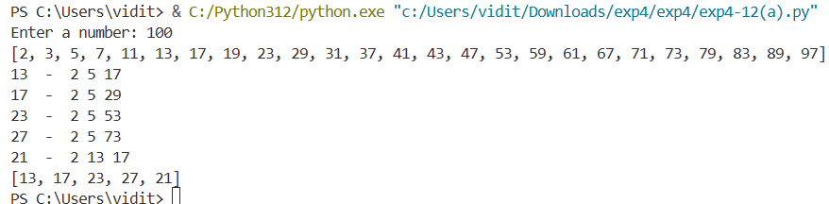
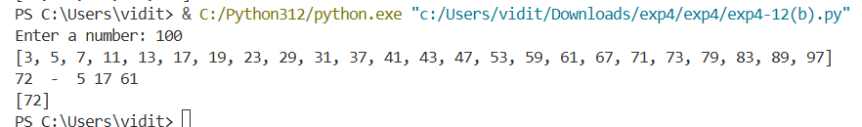

M. Find five least positive integers n such that each of the numbers n, n+1, n+2 is a product of two different primes
n = int(input("Enter a number: "))
def isPrime(n):
for i in range(2,n):
if n%i == 0: return False
return True

li = []
for i in range(2,n):
if(isPrime(i)):
li.append(i)
ans = []
for i in range(len(li)):
for j in range(i+1,len(li)):
for z in range(2,n):
if z == li[i]*li[j]:
ans.append(z)

ans.sort()
print(ans)
count = 0
res = []
for i in range(len(ans)-2):
if ans[i] + 2 == ans[i+1] + 1 == ans[i+2]:
res.append(ans[i])
result = []
for i in range(len(ans)-3):
if ans[i] + 3 == ans[i+1] + 3 == ans[i+2] + 1 == ans[i+3]:
result.append(ans[i])

print(res[0: 5])
print("PART B ======================================")
print(result)
print("PART C ======================================")
con = 0
checker = False
for i in range(len(ans)):
for j in range(len(li)):
for k in range(j+1,len(li)):
if ans[i] == li[j]*li[k]:
con = con + 1
print("Number ", ans[i], "has only 2 primes i.e ", li[j], li[k])
if con==4:
checker = True
break
if(checker): break
if(checker): break
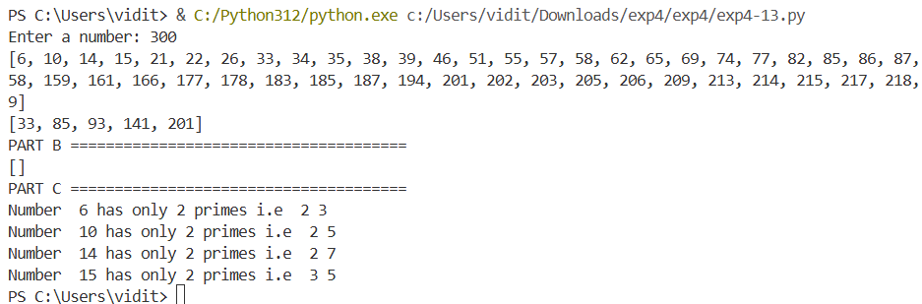

N. Find all numbers of the form 2^n-1 with positive integer n, not exceeding million, which are products of two primes
n = int(input("Enter a number: "))
def isPrime(n):
for i in range(2,n):
if n%i == 0: return False
return True

li = []
for i in range(2,n):
if(isPrime(i)):
li.append(i)
ans = []
for i in range(len(li)):
for j in range(i+1,len(li)):
for z in range(1,n):
if pow(2,z)-1 == li[i]*li[j]:
print(z,"(",pow(2,z),")", " - ", li[i],li[j])
ans.append(z)

print("PART B ===========================")

for i in range(len(li)):
for j in range(i+1,len(li)):
for k in range(j+1,len(li)):
for z in range(1,n):
if z%2 == 0 and z>4:
if pow(2,z)-1 == li[i]*li[j]*li[k]:
print(z, " - ", li[i],li[j],li[k])
ans.append(z)
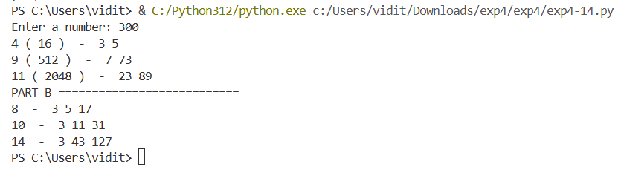

EXPERIMENT 6

A. Finding twin primes for a given n
n = int(input("Enter the value of N: "))

def isPrime(n):
for i in range(2,n):
if n%i == 0: return False
return True

li = []
for i in range(2,n):
if(isPrime(i)):
li.append(i)

ans = []

for i in range(len(li)):
for j in range(i+1, len(li)):
if(li[j] - li[i] == 2):
ans.append({li[i], li[j]})
if(li[j] - li[i] > 2):
break

print(ans)
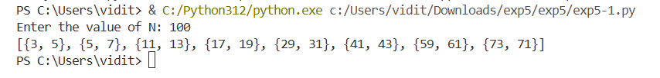

B. Finding primes for a given n of form i^2 + 1 = prime
m = int(input("Enter the value of m: "))
def isPrime(n):
for i in range(2,n):
if n%i == 0: return False
return True

li = []
for i in range(2,2000):
if(isPrime(i)):
li.append(i)

ans = []
count = 0
for i in li:
for j in range(1, 2000):
if j*j + 1 == i:
count = count + 1
ans.append((j, i))
if(count == m): break
if(count == m): break

print(ans)
C. Smallest prime factor of n! + 1
ans = []
for j in range(1, 20):
def fact(n):
if n == 0: return 1
ans = n*fact(n-1)
return ans

val = fact(j) + 1
# print(val)

def isPrime(n):
for i in range(2,n):
if n%i == 0: return False
return True

li = []
for i in range(2,2000):
if(isPrime(i)):
li.append(i)

for i in li:
if val%i == 0:
print("Smallest prime factor for the value of n as ",j, "is: ", i)
ans.append(i)
break
print(ans)
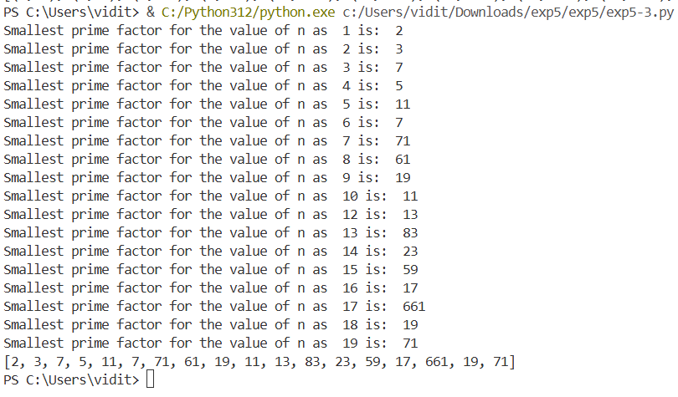

D. Determine whether a number is prime or not
n = int(input("Enter the value of n: "))
no = int(pow(n, 0.5))
# print(no)
def isPrime(n, no):
for i in range(2,no):
if n%i == 0: return False
return True
check = isPrime(n, no)
print(check)
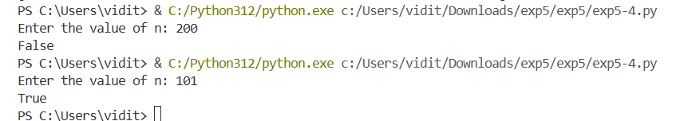

E. Euclidean algorithm to find gcd
def gcd(n1, n2):
if n2 == 0:
return n1
else:
return gcd(n2, n1%n2)

a = int(input("Enter the 1st no: "))
b = int(input("Enter the 1st no: "))

d = gcd(a, b)
print("GCD OF 2 NOS = ", d)
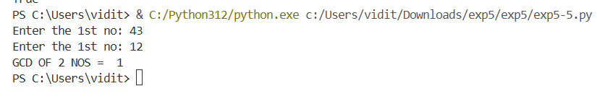
F. Set of 2 or more numbers, find their gcd
a = []
n = int(input("Enter number of values to enter: "))
print("Enter the values: ")

for i in range(n):
b = int(input())
a.append(b)

def gcd(n1, n2):
if n2 == 0:
return n1
else:
return gcd(n2, n1%n2)

d = gcd(a[0], a[1])
for i in range(2, n):
d = gcd(d, a[i])
print("GCD IS ==========================")
print(d)
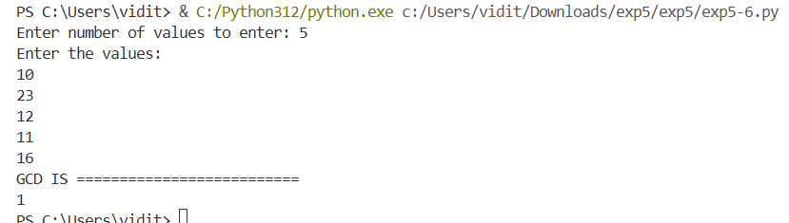

EXPERIMENT 7

A. Ceaser cipher
text = input("Enter the plaintext or message: ")

arr = {'a': 0, 'b': 1, 'c': 2, 'd': 3, 'e': 4, 'f': 5, 'g': 6, 'h': 7, 'i': 8, 'j': 9, 'k': 10, 'l': 11, 'm': 12, 'n': 13, 'o': 14, 'p': 15, 'q': 16, 'r': 17, 's': 18, 't': 19, 'u': 20, 'v': 21, 'w': 22, 'x': 23, 'y': 24, 'z': 25}

k = 3
cipher = ""
for i in range(len(text)):
value = arr[text[i]]
a = (value + k)%26
for key, value in arr.items():
if value == a:
b = key
cipher = cipher + b

print("Encryption--------------------------")
print(cipher)

plaintext = ""
for i in range(len(cipher)):
value = arr[cipher[i]]
a = (value - k)%26
for key, value in arr.items():
if value == a:
b = key
plaintext = plaintext + b
print("Decryption--------------------------")
print(plaintext)
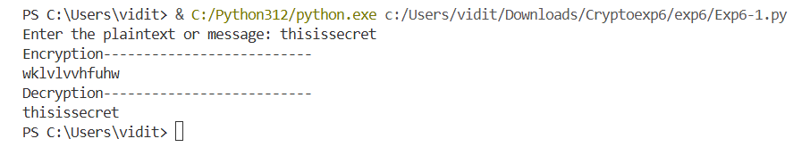

B. Monoalphabetic cipher - affine cipher
arr = {'a': 0, 'b': 1, 'c': 2, 'd': 3, 'e': 4, 'f': 5, 'g': 6, 'h': 7, 'i': 8, 'j': 9, 'k': 10, 'l': 11, 'm': 12, 'n': 13, 'o': 14, 'p': 15, 'q': 16, 'r': 17, 's': 18, 't': 19, 'u': 20, 'v': 21, 'w': 22, 'x': 23, 'y': 24, 'z': 25}

k1 = int(input("Enter the key 1 that is prime to 26: "))
k2 = int(input("Enter the key 2: "))

text = input("Enter the plaintext or message: ")

cipher = ""
for i in range(len(text)):
value = arr[text[i]]
a = (value*k1 + k2)%26
for key, value in arr.items():
if value == a:
b = key
cipher = cipher + b

print("Encryption--------------------------")
print(cipher)
c = pow(k1, -1, 26)
plaintext = ""
for i in range(len(cipher)):
value = arr[cipher[i]]
a = ((value-k2)*c)%26
for key, value in arr.items():
if value == a:
b = key
plaintext = plaintext + b

print("Decryption--------------------------")
print(plaintext)
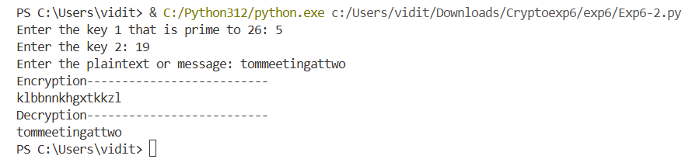

C. Playfair cipher
text = input("Enter the plaintext or message: ")
key = input("Enter the key: ")

arr = ['a', 'b', 'c', 'd', 'e', 'f', 'g', 'h', 'i', 'k', 'l', 'm', 'n', 'o', 'p', 'q', 'r', 's', 't', 'u', 'v', 'w', 'x', 'y', 'z']

def generate_key_matrix(key):
key = key.upper().replace("J", "I")
matrix = []
used = set()

for ch in key:
if ch not in used and ch.isalpha():
used.add(ch)
matrix.append(ch)

for ch in "ABCDEFGHIKLMNOPQRSTUVWXYZ":
if ch not in used:
used.add(ch)
matrix.append(ch)

return [matrix[i:i+5] for i in range(0, 25, 5)]

def find_position(matrix, ch):
for i, row in enumerate(matrix):
for j, val in enumerate(row):
if val == ch:
return i, j
return None

def prepare_text(text, for_encryption=True):
text = text.upper().replace("J", "I")
result = ""
i = 0

while i < len(text):
ch1 = text[i]
if not ch1.isalpha():
i += 1
continue
if i + 1 < len(text):
ch2 = text[i+1]
if not ch2.isalpha():
i += 1
continue
if ch1 == ch2:
result += ch1 + 'X'
i += 1
else:
result += ch1 + ch2
i += 2
else:
result += ch1 + 'X'
i += 1
return result

def playfair_encrypt(text, matrix):
text = prepare_text(text)
cipher = ""

for i in range(0, len(text), 2):
a, b = text[i], text[i+1]
r1, c1 = find_position(matrix, a)
r2, c2 = find_position(matrix, b)

if r1 == r2:
cipher += matrix[r1][(c1 + 1) % 5]
cipher += matrix[r2][(c2 + 1) % 5]
elif c1 == c2:
cipher += matrix[(r1 + 1) % 5][c1]
cipher += matrix[(r2 + 1) % 5][c2]
else:
cipher += matrix[r1][c2]
cipher += matrix[r2][c1]

return cipher

def playfair_decrypt(cipher, matrix):
plain = ""

for i in range(0, len(cipher), 2):
a, b = cipher[i], cipher[i+1]
r1, c1 = find_position(matrix, a)
r2, c2 = find_position(matrix, b)

if r1 == r2:
plain += matrix[r1][(c1 - 1) % 5]
plain += matrix[r2][(c2 - 1) % 5]
elif c1 == c2:
plain += matrix[(r1 - 1) % 5][c1]
plain += matrix[(r2 - 1) % 5][c2]
else:
plain += matrix[r1][c2]
plain += matrix[r2][c1]

return plain

matrix = generate_key_matrix(key)
print("Key Matrix:")
for row in matrix:
print(row)

print("Encryption--------------------------")
ciphertext = playfair_encrypt(text, matrix)
print("\nEncrypted:", ciphertext)

print("Decryption--------------------------")
decrypted = playfair_decrypt(ciphertext, matrix)
print("Decrypted:", decrypted)
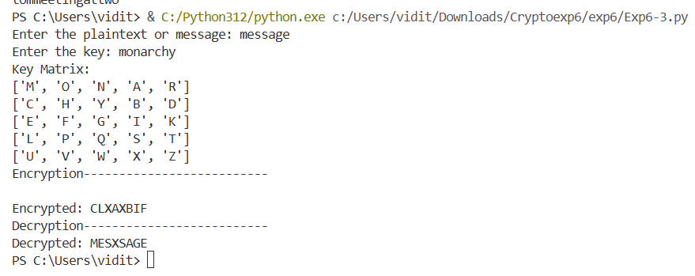
D. Hill cipher
import numpy as np

plaintext = (input("Enter the text : "))

def mod_inverse(a, m):
for x in range(1, m):
if (a * x) % m == 1:
return x
return None

def encrypt_hill_cipher(plaintext, key_matrix):
n = key_matrix.shape[0]
if len(plaintext) % n != 0:
plaintext += 'X' * (n - (len(plaintext) % n))

ciphertext = ""
for i in range(0, len(plaintext), n):
block = plaintext[i : i + n]
message_vector = np.array([ord(char) - ord('A') for char in block]).reshape(n, 1)

cipher_vector = np.dot(key_matrix, message_vector) % 26

ciphertext += "".join(chr(int(val) + ord('A')) for val in cipher_vector)
return ciphertext

def decrypt_hill_cipher(ciphertext, key_matrix):
n = key_matrix.shape[0]
det = int(round(np.linalg.det(key_matrix)))
det_mod_26 = det % 26
det_inv = mod_inverse(det_mod_26, 26)

if det_inv is None:
print("Key matrix is not invertible modulo 26. Cannot decrypt.")

adjugate_matrix = np.round(det * np.linalg.inv(key_matrix)).astype(int) % 26
inverse_key_matrix = (det_inv * adjugate_matrix) % 26

decrypted_text = ""

for i in range(0, len(ciphertext), n):
block = ciphertext[i : i + n]
cipher_vector = np.array([ord(char) - ord('A') for char in block]).reshape(n, 1)

message_vector = np.dot(inverse_key_matrix, cipher_vector) % 26

decrypted_text += "".join(chr(int(val) + ord('A')) for val in message_vector)
return decrypted_text

key_matrix_2x2 = np.array([[3, 5], [4, 7]])

encrypted_text = encrypt_hill_cipher(plaintext.upper(), key_matrix_2x2)
print(f"Plaintext: {plaintext}")
print("Encryption--------------------------")
print(f"Encrypted Text: {encrypted_text}")

print("Decryption--------------------------")
decrypted_text = decrypt_hill_cipher(encrypted_text, key_matrix_2x2)
print(f"Decrypted Text: {decrypted_text}")
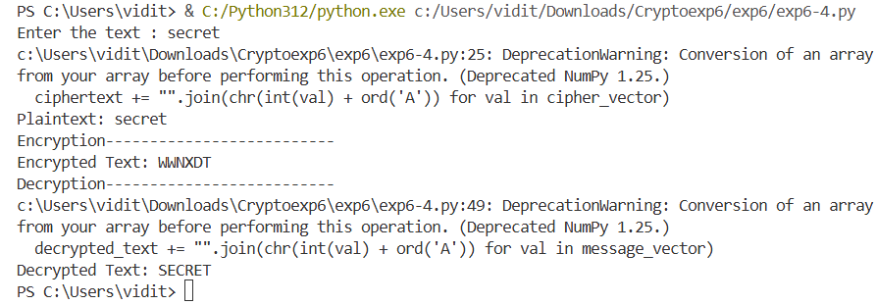

E. Vignere cipher
text = (input("Enter the text : "))
k = (input("Enter the key : "))

arr = {'a': 0, 'b': 1, 'c': 2, 'd': 3, 'e': 4, 'f': 5, 'g': 6, 'h': 7, 'i': 8, 'j': 9, 'k': 10, 'l': 11, 'm': 12, 'n': 13, 'o': 14, 'p': 15, 'q': 16, 'r': 17, 's': 18, 't': 19, 'u': 20, 'v': 21, 'w': 22, 'x': 23, 'y': 24, 'z': 25}

while(len(k)<len(text)):
if(len(k)!=len(text)):
k = k + k

cipher = ""

for i in range(len(text)):
value1 = arr[text[i]]
value2 = arr[k[i]]
a = (value1 + value2)%26
for key, value in arr.items():
if value == a:
b = key
cipher = cipher + b
print("Encoding-------------------")
print(cipher)

plaintext = ""
for i in range(len(cipher)):
value1 = arr[cipher[i]]
value2 = arr[k[i]]
a = (value1 - value2)%26
for key, value in arr.items():
if value == a:
b = key
plaintext = plaintext + b
print("Decoding-------------------")
print(plaintext)
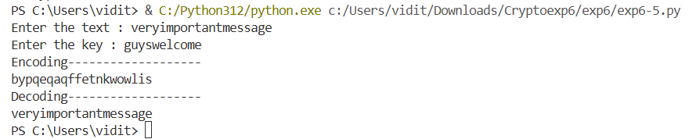

F. Autokey cipher
text = (input("Enter the text : "))
k = (input("Enter the key of size 1: "))

arr = {'a': 0, 'b': 1, 'c': 2, 'd': 3, 'e': 4, 'f': 5, 'g': 6, 'h': 7, 'i': 8, 'j': 9, 'k': 10, 'l': 11, 'm': 12, 'n': 13, 'o': 14, 'p': 15, 'q': 16, 'r': 17, 's': 18, 't': 19, 'u': 20, 'v': 21, 'w': 22, 'x': 23, 'y': 24, 'z': 25}

for i in range(len(text)):
k = k + text[i]

cipher = ""

for i in range(len(text)):
value1 = arr[text[i]]
value2 = arr[k[i]]
a = (value1 + value2)%26
for key, value in arr.items():
if value == a:
b = key
cipher = cipher + b
print("Encoding-------------------")
print(cipher)

plaintext = ""
for i in range(len(cipher)):
value1 = arr[cipher[i]]
value2 = arr[k[i]]
a = (value1 - value2)%26
for key, value in arr.items():
if value == a:
b = key
plaintext = plaintext + b
print("Decoding-------------------")
print(plaintext)
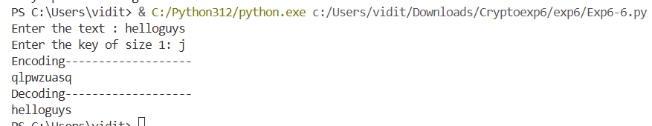

G. Vernam cipher
text = (input("Enter the text : "))
k = (input("Enter the key of same size: "))

arr = {'a': 0, 'b': 1, 'c': 2, 'd': 3, 'e': 4, 'f': 5, 'g': 6, 'h': 7, 'i': 8, 'j': 9, 'k': 10, 'l': 11, 'm': 12, 'n': 13, 'o': 14, 'p': 15, 'q': 16, 'r': 17, 's': 18, 't': 19, 'u': 20, 'v': 21, 'w': 22, 'x': 23, 'y': 24, 'z': 25}

cipher = ""
for i in range(len(text)):
value1 = arr[text[i]]
value2 = arr[k[i]]
a = (value1^value2)%26
for key, value in arr.items():
if value == a:
b = key
cipher = cipher + b

print("Encoding------------------")
print(cipher)
plaintext = ""
for i in range(len(cipher)):
value1 = arr[cipher[i]]
value2 = arr[k[i]]
a = (value1^value2)%26
for key, value in arr.items():
if value == a:
b = key
plaintext = plaintext + b

print("Decoding------------------")
print(plaintext)
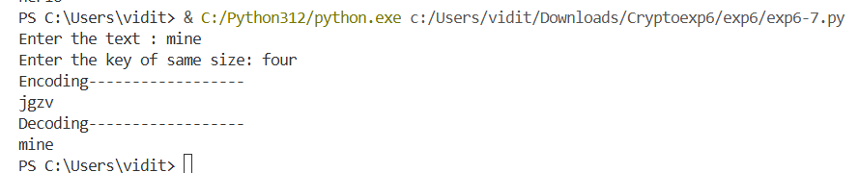

H. One time pad cipher
text = (input("Enter the text : "))
k = (input("Enter the key of the same size : "))

arr = {'a': 0, 'b': 1, 'c': 2, 'd': 3, 'e': 4, 'f': 5, 'g': 6, 'h': 7, 'i': 8, 'j': 9, 'k': 10, 'l': 11, 'm': 12, 'n': 13, 'o': 14, 'p': 15, 'q': 16, 'r': 17, 's': 18, 't': 19, 'u': 20, 'v': 21, 'w': 22, 'x': 23, 'y': 24, 'z': 25}

cipher = ""

for i in range(len(text)):
value1 = arr[text[i]]
value2 = arr[k[i]]
a = (value1 + value2)%26
for key, value in arr.items():
if value == a:
b = key
cipher = cipher + b
print("Encoding-------------------")
print(cipher)

plaintext = ""
for i in range(len(cipher)):
value1 = arr[cipher[i]]
value2 = arr[k[i]]
a = (value1 - value2)%26
for key, value in arr.items():
if value == a:
b = key
plaintext = plaintext + b
print("Decoding-------------------")
print(plaintext)
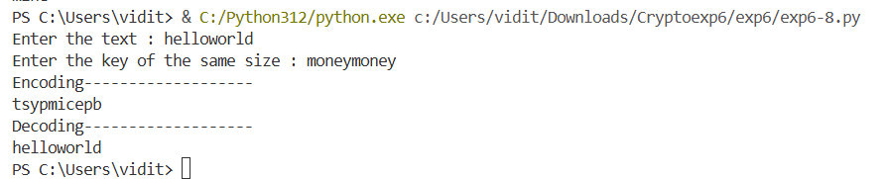

I. Kasiksi method
def vignere(plaintext, key):
ciphertext = ""
key_index = 0
for char in plaintext:
if 'A' <= char <= 'Z':
shift = ord(key[key_index % len(key)].upper()) - ord('A')
encrypted_char = chr(((ord(char) - ord('A') + shift) % 26) + ord('A'))
ciphertext += encrypted_char
key_index += 1
elif 'a' <= char <= 'z':
shift = ord(key[key_index % len(key)].lower()) - ord('a')
encrypted_char = chr(((ord(char) - ord('a') + shift) % 26) + ord('a'))
ciphertext += encrypted_char
key_index += 1
else:
ciphertext += char
return ciphertext

def find_repeated_sequences(ciphertext, min_length=3):
repetitions = {}
for i in range(len(ciphertext) - min_length + 1):
sequence = ciphertext[i:i+min_length]
for j in range(i + min_length, len(ciphertext) - min_length + 1):
if ciphertext[j:j+min_length] == sequence:
if sequence not in repetitions:
repetitions[sequence] = []
repetitions[sequence].append(j - i)
return repetitions

def calculate_gcd(a, b):
while b:
a, b = b, a % b
return a

def estimate_key_length_kasiski(ciphertext, min_sequence_length=3):
repetitions = find_repeated_sequences(ciphertext, min_sequence_length)

distances = []
for seq, dists in repetitions.items():
distances.extend(dists)

if not distances:
return None

current_gcd = distances[0]
for i in range(1, len(distances)):
current_gcd = calculate_gcd(current_gcd, distances[i])

return current_gcd

long_plaintext = "THISISAMUCHLONGERTEXTTOILLUSTRATETHEKASISKIMETHODBETTER"
long_plaintext.lower()
long_key = "SECRET"
long_key.lower()
long_ciphertext = vignere(long_plaintext, long_key)
print(f"\nLong Ciphertext for Kasiski: {long_ciphertext}")

estimated_key_length = estimate_key_length_kasiski(long_ciphertext)
print(f"Estimated Key Length (Kasiski Method): {estimated_key_length}")
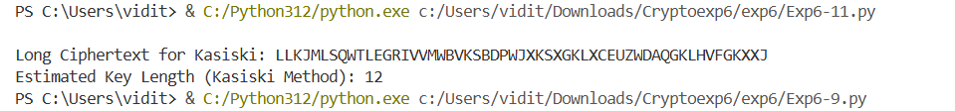

J. Rail fence cipher
text = (input("Enter the text : "))

t1 = ""
t2 = ""
for i in range(len(text)):
if i%2==0:
t1 = t1 + text[i]
else:
t2 = t2 + text[i]

cipher = t1 + t2
print("Encoding-------------------")
print(cipher)
plaintext = ""
n = len(cipher)
n1 = ""
n2 = ""
if(n%2 !=0):
for i in range(n):
if(i >= int(n/2 + 1)):
n2 = n2 + cipher[i]
else:
n1 = n1 + cipher[i]

j = 0
k = 0
for i in range(n):
if(i%2 == 0):
plaintext = plaintext + n1[j]
j = j+1
else:
plaintext = plaintext + n2[k]
k = k + 1
print("Decoding-------------------")
print(plaintext)
else:
for i in range(n):
if(i >= int(n/2)):
n2 = n2 + cipher[i]
else:
n1 = n1 + cipher[i]

j = 0
k = 0
for i in range(n):
if(i%2 == 0):
plaintext = plaintext + n1[j]
j = j+1
else:
plaintext = plaintext + n2[k]
k = k + 1
print("Decoding-------------------")
print(plaintext)

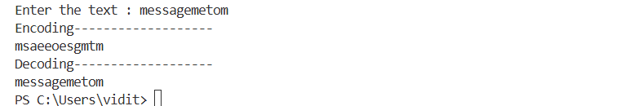
K. Row column transposition cipher
text = (input("Enter the text : "))
k = (input("Enter the key as per no.of columns required: "))

arr = {'a': 0, 'b': 1, 'c': 2, 'd': 3, 'e': 4, 'f': 5, 'g': 6, 'h': 7, 'i': 8, 'j': 9, 'k': 10, 'l': 11, 'm': 12, 'n': 13, 'o': 14, 'p': 15, 'q': 16, 'r': 17, 's': 18, 't': 19, 'u': 20, 'v': 21, 'w': 22, 'x': 23, 'y': 24, 'z': 25}

a = []
for i in range(len(k)):
temp = []
temp.append(arr[k[i]])
temp.append(i)
a.append(temp)
print(a)
count = 0
cip = []
while(True):
if count >= len(text): break
temp = []
for i in range(len(k)):
if count >= len(text):
count = count + 1
temp.append('x')
else:
temp.append(text[count])
count = count + 1
cip.append(temp)

print(cip)

a.sort()
print(a)

cipher = ""

count = 0
k = 0
while(True):
if(count == len(cip)*len(cip[0])): break
for i in range(len(cip)):
cipher = cipher + cip[i][a[k][1]]
count = count + 1
k = k+1
print("Encryption-----------------------")
print(cipher)

plain = []
for i in range(int(len(cipher)/len(a))):
temp = []
for j in range(len(a)):
temp.append(0)
plain.append(temp)

plaintext = ""
count = 0
k = 0
for i in range(len(a)):
m = a[i][1]
for j in range(int(len(cipher)/len(a))):
plain[j][m] = cipher[count]
count = count + 1

print("Decryption-----------------------")
print(plain)
for i in range(len(plain)):
for j in range(len(plain[0])):
plaintext = plaintext + plain[i][j]
print(plaintext)
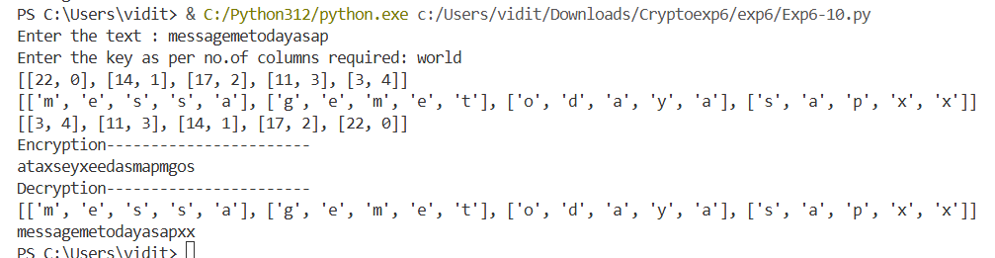

L. 2 substitutions cipher
text = (input("Enter the text : "))
k2 = (input("Enter the key of same size: "))
arr = {'a': 0, 'b': 1, 'c': 2, 'd': 3, 'e': 4, 'f': 5, 'g': 6, 'h': 7, 'i': 8, 'j': 9, 'k': 10, 'l': 11, 'm': 12, 'n': 13, 'o': 14, 'p': 15, 'q': 16, 'r': 17, 's': 18, 't': 19, 'u': 20, 'v': 21, 'w': 22, 'x': 23, 'y': 24, 'z': 25}

k1 = 3
cipher = ""
for i in range(len(text)):
value = arr[text[i]]
a = (value + k1)%26
for key, value in arr.items():
if value == a:
b = key
cipher = cipher + b

print("Encryption--------------------------")
print(cipher)

cipher2 = ""
for i in range(len(cipher)):
value1 = arr[cipher[i]]
value2 = arr[k2[i]]
a = (value1^value2)%26
for key, value in arr.items():
if value == a:
b = key
cipher2 = cipher2 + b

print("Encoding------------------")
print(cipher2)

plaintext = ""
for i in range(len(cipher2)):
value1 = arr[cipher2[i]]
value2 = arr[k2[i]]
a = (value1^value2)%26
for key, value in arr.items():
if value == a:
b = key
plaintext = plaintext + b

print("Decoding------------------")
print(plaintext)

plaintext1 = ""
for i in range(len(plaintext)):
value = arr[plaintext[i]]
a = (value - k1)%26
for key, value in arr.items():
if value == a:
b = key
plaintext1 = plaintext1 + b
print("Decryption--------------------------")
print(plaintext1)
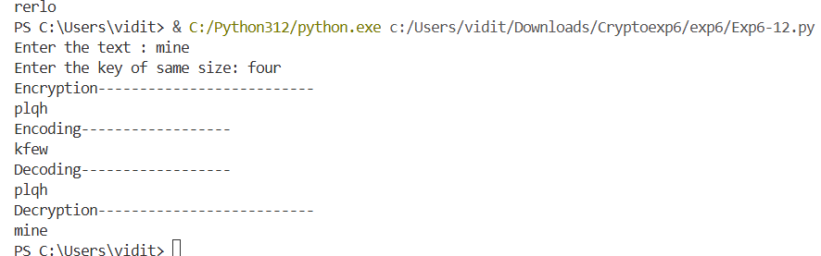

M. 2 transpositions cipher
arr = {'a': 0, 'b': 1, 'c': 2, 'd': 3, 'e': 4, 'f': 5, 'g': 6, 'h': 7, 'i': 8, 'j': 9, 'k': 10, 'l': 11, 'm': 12, 'n': 13, 'o': 14, 'p': 15, 'q': 16, 'r': 17, 's': 18, 't': 19, 'u': 20, 'v': 21, 'w': 22, 'x': 23, 'y': 24, 'z': 25}

text = (input("Enter the text : "))

t1 = ""
t2 = ""
for i in range(len(text)):
if i%2==0:
t1 = t1 + text[i]
else:
t2 = t2 + text[i]

cipher = t1 + t2
print("Encoding-------------------")
print(cipher)

k = (input("Enter the key as per no.of columns required: "))

a = []
for i in range(len(k)):
temp = []
temp.append(arr[k[i]])
temp.append(i)
a.append(temp)
print(a)
count = 0
cip = []
while(True):
if count >= len(cipher): break
temp = []
for i in range(len(k)):
if count >= len(cipher):
count = count + 1
temp.append('x')
else:
temp.append(cipher[count])
count = count + 1
cip.append(temp)

print(cip)
a.sort()
print(a)

cipher2 = ""

count = 0
k = 0
while(True):
if(count == len(cip)*len(cip[0])): break
for i in range(len(cip)):
cipher2 = cipher2 + cip[i][a[k][1]]
count = count + 1
k = k+1
print("Encryption-----------------------")
print(cipher2)
plain = []
for i in range(int(len(cipher2)/len(a))):
temp = []
for j in range(len(a)):
temp.append(0)
plain.append(temp)

plaintext = ""
count = 0
k = 0
for i in range(len(a)):
m = a[i][1]
for j in range(int(len(cipher2)/len(a))):
plain[j][m] = cipher2[count]
count = count + 1

print("Decryption-----------------------")
print(plain)
for i in range(len(plain)):
for j in range(len(plain[0])):
plaintext = plaintext + plain[i][j]
print(plaintext)

plaintext1 = ""
n = len(plaintext)
n1 = ""
n2 = ""
if(n%2 !=0):
for i in range(n):
if(i >= int(n/2 + 1)):
n2 = n2 + plaintext[i]
else:
n1 = n1 + plaintext[i]

j = 0
k = 0
for i in range(n):
if(i%2 == 0):
plaintext1 = plaintext1 + n1[j]
j = j+1
else:
plaintext1 = plaintext1 + n2[k]
k = k + 1
print("Decoding-------------------")
print(plaintext)
else:
for i in range(n):
if(i >= int(n/2)):
n2 = n2 + plaintext[i]
else:
n1 = n1 + plaintext[i]

j = 0
k = 0
for i in range(n):
if(i%2 == 0):
plaintext1 = plaintext1 + n1[j]
j = j+1
else:
plaintext1 = plaintext1 + n2[k]
k = k + 1
print("Decoding-------------------")
print(plaintext1)
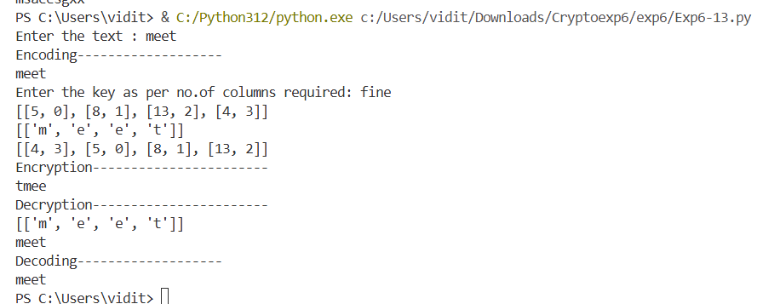

N. substitution + transposition cipher
text = (input("Enter the text : "))
arr = {'a': 0, 'b': 1, 'c': 2, 'd': 3, 'e': 4, 'f': 5, 'g': 6, 'h': 7, 'i': 8, 'j': 9, 'k': 10, 'l': 11, 'm': 12, 'n': 13, 'o': 14, 'p': 15, 'q': 16, 'r': 17, 's': 18, 't': 19, 'u': 20, 'v': 21, 'w': 22, 'x': 23, 'y': 24, 'z': 25}

k = 3
cipher = ""
for i in range(len(text)):
value = arr[text[i]]
a = (value + k)%26
for key, value in arr.items():
if value == a:
b = key
cipher = cipher + b

print("Encryption--------------------------")
print(cipher)

t1 = ""
t2 = ""
for i in range(len(cipher)):
if i%2==0:
t1 = t1 + cipher[i]
else:
t2 = t2 + cipher[i]

cipher2 = t1 + t2
print("Encoding-------------------")
print(cipher2)

plaintext = ""
n = len(cipher2)
n1 = ""
n2 = ""
if(n%2 !=0):
for i in range(n):
if(i >= int(n/2 + 1)):
n2 = n2 + cipher2[i]
else:
n1 = n1 + cipher2[i]

j = 0
k = 0
for i in range(n):
if(i%2 == 0):
plaintext = plaintext + n1[j]
j = j+1
else:
plaintext = plaintext + n2[k]
k = k + 1
print("Decoding-------------------")
print(plaintext)
else:
for i in range(n):
if(i >= int(n/2)):
n2 = n2 + cipher2[i]
else:
n1 = n1 + cipher2[i]

j = 0
k = 0
for i in range(n):
if(i%2 == 0):
plaintext = plaintext + n1[j]
j = j+1
else:
plaintext = plaintext + n2[k]
k = k + 1
print("Decoding-------------------")
print(plaintext)

k = 3
plaintext1 = ""
for i in range(len(plaintext)):
value = arr[plaintext[i]]
a = (value - k)%26
for key, value in arr.items():
if value == a:
b = key
plaintext1 = plaintext1 + b
print("Decryption--------------------------")
print(plaintext1)
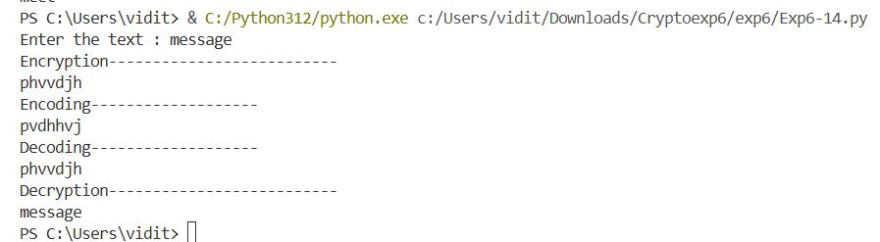

EXPERIMENT 8

A. Diffie hellman key exchange
p = int(input("Enter prime p: "))
privA = int(input("Alice enter your private key: "))
g = int(input("Enter generator g: "))
privB = int(input("Bob enter your private key: "))

temp1 = pow(g, privA)%p
temp2 = pow(g, privB)%p
print(temp1, temp2)

keyA = temp2
keyB = temp1

Ka = pow(keyA, privA)%p
Kb = pow(keyB, privB)%p

if(Ka == Kb): print("Encryption has been successfully implemented")
print(Ka, "is the shared secret key")
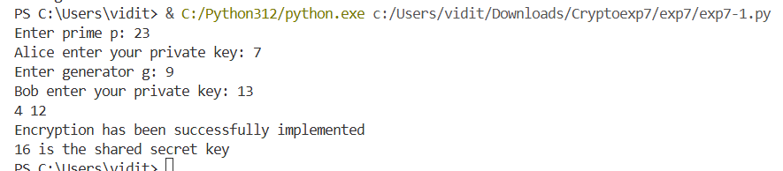

B. Elgamal
import random

def gcd(a, b):
while b != 0:
a, b = b, a % b
return a

p = int(input("Enter a prime number: "))
g = random.randint(1, p - 2)

private = random.randint(2, p-2)
h = pow(g, private)%p

m = int(input("Enter a message: "))
k = random.randint(2, p-2)
c1 = pow(g, k)%p
c2 = (m*pow(h, k))%p
print("Encryption-------------")
print(c1, c2)

print("Decryption-------------")
s = pow(c1, private)%p
m = (c2 * pow(s, -1, p))%p
print(m)
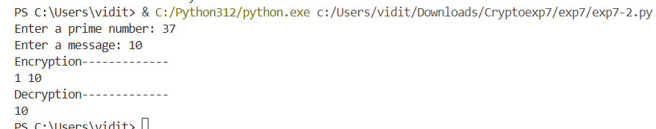

C. RSA
def gcd(a, b):
while b != 0:
a, b = b, a % b
return a

p = int(input("Enter a prime number: "))
q = int(input("Enter a prime number: "))
n = p*q
phi = (p-1)*(q-1)
print(n, phi)
e = 0

arr = {'a': 0, 'b': 1, 'c': 2, 'd': 3, 'e': 4, 'f': 5, 'g': 6, 'h': 7, 'i': 8, 'j': 9, 'k': 10, 'l': 11, 'm': 12, 'n': 13, 'o': 14, 'p': 15, 'q': 16, 'r': 17, 's': 18, 't': 19, 'u': 20, 'v': 21, 'w': 22, 'x': 23, 'y': 24, 'z': 25}

text = (input("Enter the text : "))

t1 = ""
t2 = ""
for i in range(len(text)):
if i%2==0:
t1 = t1 + text[i]
else:
t2 = t2 + text[i]

cipher = t1 + t2
print("Encoding-------------------")
print(cipher)
for e in range(2, phi):
if gcd(e, phi) == 1:
break

def modInv(e, phi):
for d in range(2, phi):
if((d*e)%phi == 1):
return d
return -1

d = modInv(e, phi)

m = int(input("Enter a message: "))
print(e, d)
print("Encryption------------------")
c = pow(m, e)%n
print(c)
print("Decryption------------------")
m = pow(c, d)%n
print(m)
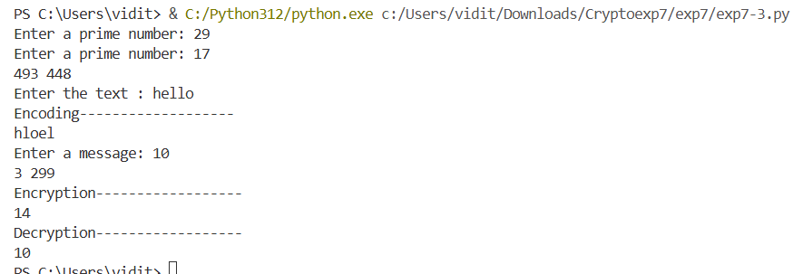

D. Pseudo random key generation
def gcd(a, b):
while b != 0:
a, b = b, a % b
return a

p = int(input("Enter a prime number: "))
q = int(input("Enter a prime number: "))
n = p*q
phi = (p-1)*(q-1)
print(n, phi)
e = 0

for e in range(2, phi):
if gcd(e, phi) == 1:
break

def modInv(e, phi):
for d in range(2, phi):
if((d*e)%phi == 1):
return d
return -1

d = modInv(e, phi)

for x in range(2, n):
if(gcd(x, n) == 1): break

print("pseudorandom generation based on rsa are: ")
for i in range(5):
x = pow(x, e)%n
print(x)
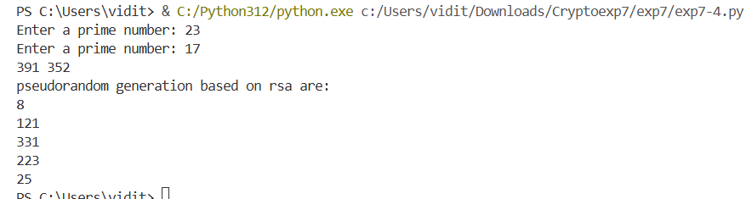
E. SHA1
import hashlib

str = input("Enter a message: ")
result = hashlib.sha1(str.encode())

print("The hexadecimal equivalent of SHA1 is : ")
print(result.hexdigest())
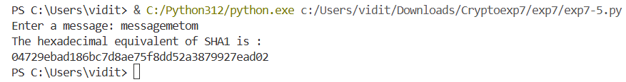

F. MD5
import hashlib

str = input("Enter a message: ")
res = hashlib.md5(str.encode())
print(res.hexdigest())

G. HMAC
import hmac
import hashlib

str1 = input("Enter a secret key: ")
str2 = input("Enter a message: ")
secret_key = b'str1'
message = b'str2'

mac = hmac.new(secret_key, message, hashlib.sha256)
mac_digest = mac.digest()
mac_hexdigest = mac.hexdigest()
print(f"MAC digest: {mac_digest}")
print(f"MAC hexdigest: {mac_hexdigest}")
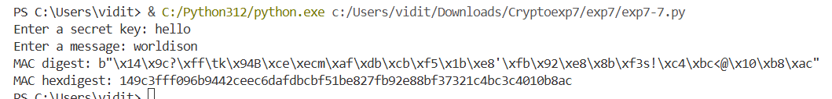
H. RSA digital signature
def gcd(a, b):
while b != 0:
a, b = b, a % b
return a

p = int(input("Enter a prime number: "))
q = int(input("Enter a prime number: "))
n = p*q
phi = (p-1)*(q-1)
print(n, phi)
e = 0

for e in range(2, phi):
if gcd(e, phi) == 1:
break

def modInv(e, phi):
for d in range(2, phi):
if((d*e)%phi == 1):
return d
return -1

d = modInv(e, phi)

m = int(input("Enter a message: "))
print(e, d)
print("Digital signature is: ")
s = pow(m, d)%n
print(s)
m1 = pow(s, e)%n
if(m1==m): print("Digital signature has been successfully created!")
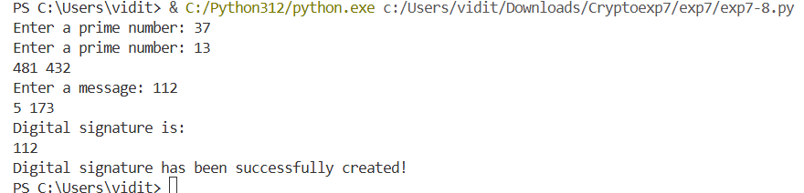

I. Elgamal digital signature
import random

def gcd(a, b):
if b==0:
return a
else: return gcd(b, a%b)

def generate_keys(q):
g = random.randint(2, q - 1)
x_a = random.randint(2, q - 2)
y_a = pow(g, x_a, q)
return (q, g, y_a), x_a

def mod_inverse(a, m):
for x in range(1, m):
if (a * x) % m == 1:
return x
return None

def sign_message(message_hash, public_key, private_key):
q, g, y_a = public_key
x_a = private_key
while True:
k = random.randint(2, q - 2)
if gcd(k, q - 1) == 1:
break
r = pow(g, k, q)
k_inv = mod_inverse(k, q - 1)
s = (message_hash - x_a * r) * k_inv % (q - 1)
return (r, s)

def verify_signature(message_hash, signature, public_key):
q, g, y_a = public_key
r, s = signature
if not (0 < r < q and 0 <= s < q - 1):
return False
v1 = (pow(y_a, r, q) * pow(r, s, q)) % q
v2 = pow(g, message_hash, q)
return v1 == v2

q = int(input("Enter a prime no: "))
public_key, private_key = generate_keys(q)
print(f"Public Key (q, g, y_a): {public_key}")
print(f"Private Key (x_a): {private_key}")
original_message_hash = int(input("Enter a number b/w 1 and prime-2: "))

signature = sign_message(original_message_hash, public_key, private_key)
print(f"Signature (r, s): {signature}")
is_valid = verify_signature(original_message_hash, signature, public_key)
print(f"Signature is valid: {is_valid}")
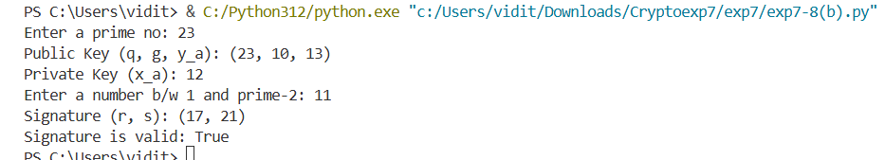

J. Schnorr digital signature
import random

PRIMENO = int(input("Enter a prime no: "))
generator = int(input("Enter a generator number "))

secretVal = random.randint(1, 97)

X = pow(generator, secretVal) % PRIMENO
y = random.randint(1, 97)
Y = pow(generator, y) % PRIMENO

print("secretVal(secret)= ", secretVal)
print("X= ", X)
print("y=", y)
print("Y=", Y)

c = random.randint(1, 97)
print("c=", c)

z = (y + c * secretVal)
print("z=", z)

val1 = pow(generator, z) % PRIMENO
val2 = (Y * (X**c)) % PRIMENO
print("val1= ", val1, end=' ')
print(" val2= ", val2)

if (val1 == val2):
print("Proven")
else:
print("Failure to prove")

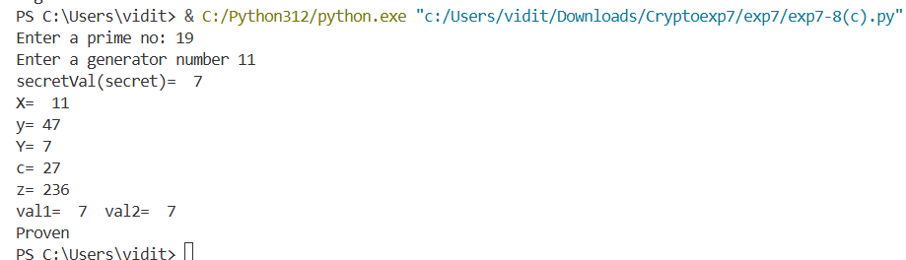

EXPERIMENT 9

Elliptic Curve cryptography
from tinyec import registry
import secrets
import random

def compress(publicKey):
return hex(publicKey.x) + hex(publicKey.y % 2)[2:]

curve = registry.get_curve('brainpoolP256r1')
Ka = secrets.randbelow(curve.field.n)
X = curve.g
Pubx = Ka * curve.g
print(Ka)
print("-----------------------------------------------------------------------------------------")
# print(X)
# print("-----------------------------------------------------------------------------------------")
print("\n")
print("Public key of X is: ", Pubx)
print("-----------------------------------------------------------------------------------------")
print("\n")
# print("X:", compress(Pubx))
# print("-----------------------------------------------------------------------------------------")
# print("\n")
Kb = secrets.randbelow(curve.field.n)
Y = curve.g
Puby = Kb * curve.g
print(Kb)
print("-----------------------------------------------------------------------------------------")
# print(Y)
# print("-----------------------------------------------------------------------------------------")
print("\n")
print("Public key of Y is: ", Puby)
print("-----------------------------------------------------------------------------------------")
print("\n")
# print("Y:", compress(Puby))
# print("-----------------------------------------------------------------------------------------")
# print("\n")

temp1 = Puby
temp2 = Pubx

sharedKa = temp1 * Ka

sharedKb = temp2 * Kb

# print("Shared key of X: ", sharedKa)
# print("\n")
# print("-----------------------------------------------------------------------------------------")
# print("Shared key of Y: ",sharedKb)
# print("\n")
# print("-----------------------------------------------------------------------------------------")
print("\n")

print(compress(sharedKa))
print(compress(sharedKb))

print("\n")
new = secrets.randbelow(curve.field.n)
m = new*curve.g
print("-----------------------------------------------------------------------------------------")
print("\n")
print("Message is =========== ", m)
print("-----------------------------------------------------------------------------------------")
print("\n")

k = random.randint(1, 27)
C1 = k*curve.g
C2 = k*Puby + m

print("Cipher 1 is ======= ", C1)
print("-----------------------------------------------------------------------------------------")
print("Cipher 2 is ======= ", C2)
print("-----------------------------------------------------------------------------------------")
print("-----------------------------------------------------------------------------------------")
print(C2 - C1*Kb)
print("-----------------------------------------------------------------------------------------")
print(m)

